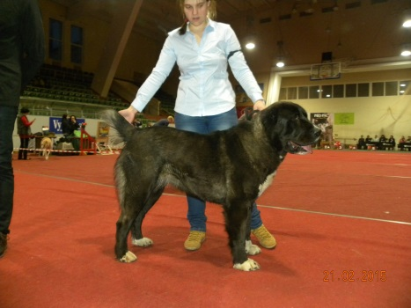  Orošon Fatiha Gruodas  Inter Multi CH  HD/ED: A/0 | 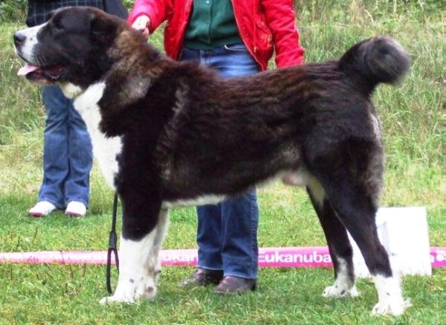  Jaunzembek Olmaz  LT-LV-EST-BALT JCH  HD/ED: A/0 | 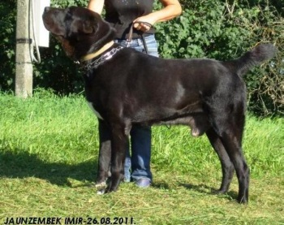  Jaunzembek Imir  LT-EST-LV-BALT JCH-CH  HD/ED: A/0 | 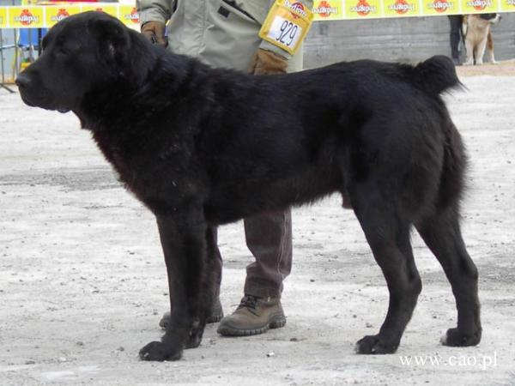  Mavr | 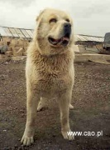  Turgay
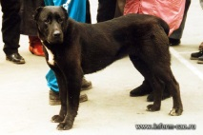
Zhana D‘Ark iz Russkoj legendy
 |  |  | 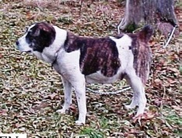  Alsira Juren HD/ED: C/0 | Bainak Aikazgi HD/ED: A/0
 |  |  |  | Nargiz Jurdo HD/ED: A/0
 |  | 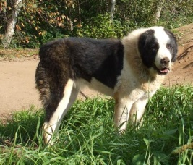  Fairona Eldo  HD/ED: B/D 0/1 | 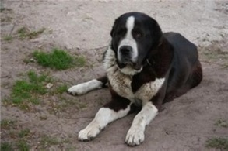  Nurek Jurdo HD/ED: A/0 | Ahmed
 |  |  |  | Tagira Jurdo HD/ED: A/0
 |  |  | 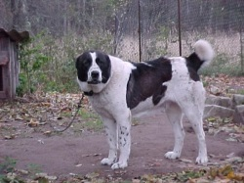  Čanhiza HD/ED: C/0 | Batiš HD/ED: B/0
 |  |  |  | Isana Metal
 | 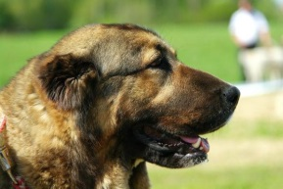  Gurta Mal Auksinis fazanas  LT JCH, LT-EST-LV-BALT CH  HD/ED: A/0 | 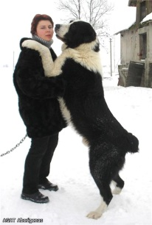  Agat Aborigenas HD/ED: A/0  LT CH | 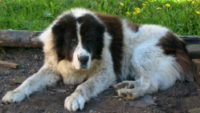  Bardas iš Agluonėnų | 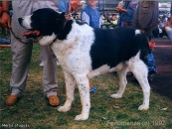  Mersis
 |  |  |  | Dingė
 |  |  | Bona | Mamy Han
 |  |  |  | Zuhra
 |  | 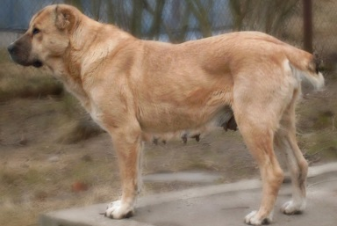  Alša Kiršinas HD/ED: D/0 | 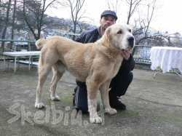  Nektar iz Aleksandrovoi slobody HD/ED: B/0 | Chainaz iz Aleksandrovoi slobody
 |  |  |  | Zargul iz Aleksandrovoi slobody
 |  |  | Erna Kiršinas | Alabaj Aždar
 |  |  |  | Čika Kiršinas

